A COMPREHENSIVE REVIEW IN BRAIN-COMPUTER INTERFACE(BCI) ON STROKE REHABILIATION

ABSTRACT :

Brain-computer interface(BCI) is a remarkable technology which promotes communication between brain and the external devices. These interfaces converts the central nervous system signals into commands for external devices. It has been the focus in recent years. BCI offering revolutionary support to the patients struggling with motor and communication impairments owing to neurological conditions like stroke, spinal cord injuries, and neurodegenerative disorders. Bioamplifiers play a vital role in stroke rehabilitation by amplifying subtle the neural and muscular signals generated by the brain and muscles, provide valuable feedback to both patients and therapists, significantly contributing to stroke rehabilitation.

KEY WORDS :

Brain Machine Interface(BCI), bioamplifiers, brain stroke, communication with external devices, electroencephalography(EEG),brain signals, Bioamp

INTRODUCTION :

BCI system uses the brain activity, interpret it, use it to control the external devices and enable the people to interact with their environment even if they are physically challenged people. Normally, people use peripheral nerves and muscles to communicate with their surrounding environments. This necessary for survival comes with severe neurological diseases, including Amyotrophic Lateral Sclerosis(ALS) and brainstem stroke, etc. BCIs work by capturing brain signals, typically through non-invasive methods like electroencephalography (EEG), which measures electrical activity on the scalp. These signals are then processed and translated into commands that control external devices. These technologies enable users to interact directly with the devices and prostheses. Our primary objective is to see the fundamentals of neuroscience in BCI technology on sensory disorders. Key applications include restoring movement for people with paralysis, enabling communication for those with severe motor impairments and virtual reality experiences. Future developments aim to create more intuitive and seamless BCI systems, expand their accessibility through wireless and portable technologies, and integrate them with other emerging technologies like artificial intelligence and augmented reality.

SIGNAL ACQUISITION:

Signal acquisition is the first step in BCI(Brain-Computer Interface).This process involves measuring the activity of brain using the devices such as scalp EGG, fMRI and intracranial electrode recordings. The first and essential component of the BCI system is signal acquisition this involves measuring brain signals using sensory modalities such as scalp electrodes, fMRI for metabolic activity, and intracranial electrodes to measure physiological behaviour. The brain – world interactions is relies on the use of electrodes which can be placed non-invasively to the surface of the scalp or implanted subdermal. Non-invasive methods, reliant on conductive gel, facilitate signal acquisition they entail setup time and may have a reduced sensitivity to higher frequencies.

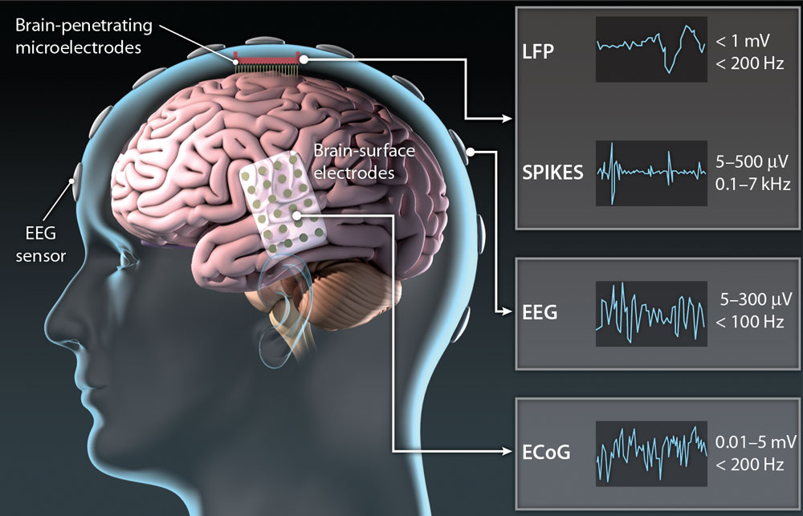

Dry electrodes enable faster application but are easily disrupted by movement.

Bipolar mode focuses on the potential differences between electrode pairs, with each pair forming a different channel. The approach helps the experts to communicate clearly and work effectively in the following field .After these sensitive sensors detect the subtle fluctuations in brain activity the signal is amplified, this amplified signal is adapted into the digital domain, analogous to transcribing the intricate melody of brain activity into a language computers can comprehend . By using greater sample rates measured in Hertz, researchers can capture more neural fluctuations. By adding more EEG sensors gives a clear and wider view of brain activity .

SIGNAL PROCESSING :

During EEG recordings unwanted signals called artifacts can interfere in brain activity. Artifacts are nothing but the movement that occur within oru body (for example: blink of eyes, movement of muscle and a beat of a heart) or from outside of the body ( for example: power lines, equipment noise) . To clear up these signals filtering technique is employed and this technique helps to remove the repeated patterns and artifacts .Once the signal is cleared up it can be analysed. But with so much data the important information should be extracted that can distinguish intentional brain activity from background noise. And this process is termed to be feature extraction which transforms the data into a special format that makes the computer to understand easily and make prediction accurate.

THIS PROCESS INVLOVES 3 STEPS

PRE PROCESSING:

NOISE REDUCTION:

Brains are always contaminated by some source of noises for example power line interference, muscle activity and eye blinks. Filtering , Independent component analysis (ICA) and Common average referencing ( CAR) are some of the techniques that helps to remove the artifacts and make the artifacts in an simpler form .

FEATURE EXTRACTION

Feature extraction is a process in a single procession that involves identifying and extraction of meaningful patterns or features from brain signals .These signals are used to classify or interpret the brain signals. Brain signals have many channels and samples that makes them difficult to analyse so that the feature extraction helps to reduce the dimensionality of the data. By using the relevant features BCI’s can more accurately classify the brain signals and detect user intentions feature extraction help the BCI to more powerful to noise , artifacts and brain signals variation .

CLASSIFICATION:

Classification is one of the process in signal processing that involves in assigning a label or category to set the signals of the brain based on the features.

Classify the brain signals to detect the user intentions such as the movement or attention. control device use the classification results to control the device such as computer. Communication enable the users to communicate through classification based or other interface.

IMPLEMENTING BIOAMP TECHNOLOGY IN STROKE DETECTION :

The Bio AMP band can be used to find brain strokes by analysing the EEG signals which shows the abnormal activities in brain caused by restricted blood flow.

The process of finding the EEG signals starts with placing the Bio AMP electrodes on the scalp in specific areas of the scalp following the 10-20EEG electrode placement system to make sure that data collection is accurate. The Bio AMP band is connected to a microcontroller for example Arduino or ESP32 to obtain EEG patterns which are further analysed using signal processing tools like MATLAB, Python or Open BCI GUI.

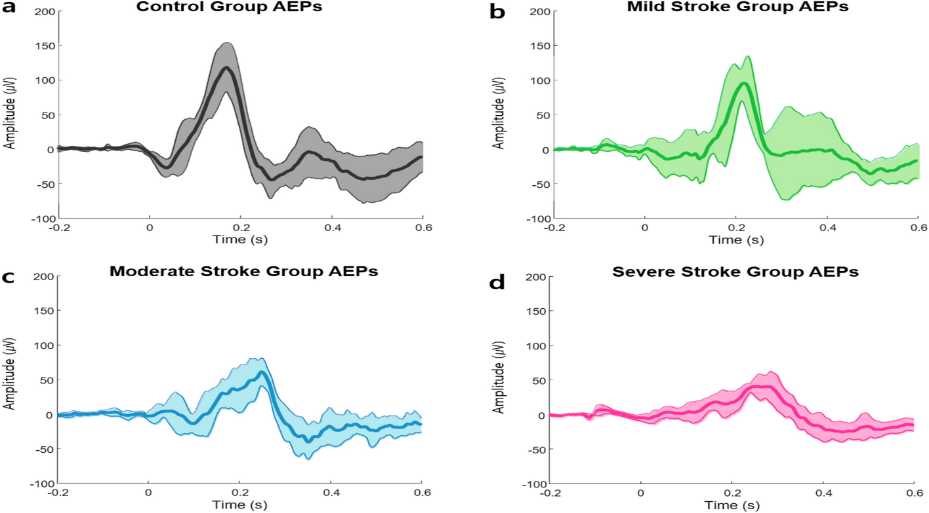

The stroke related EEG patterns shows a reduction in alpha waves 8-12Hz and an increase in delta waves 0.5-4Hz and significant asymmetry between brain hemispheres. Extracting feature techniques such as PSD and wavelet transform analysis which helps us to find irregularities. We can also use machine learning algorithm such as SVM or random forest classifiers to get EEG data more accurately

while the Bio AMP band can be only used to find early stage of stroke by absorbing slight changes in brain signals it cannot replace traditional way of finding the stroke such as CT or MRI scans. Though it is not feasible for everyone to have an access for MRI and CT scans because of the high cost and availability of these scanning techniques in every clinics or hospitals.

By using the Bio AMP techniques not only strokes can be diagnosed but also various diseases like heart conditions, neurological disorders and sleeping disorders which are related to brain signals

CONCLUSION :

Brain Machine interface (BCI) technology has transformative potential to holds the full potential to revolutionized by empowering the persons with Conceptual or physical limitations to gain independence for the persons. By tackling the variability in BCI system and incorporating brain stimulating strategies will be crucial for optimizing the restoration outcomes. The integration of BCI technology with robotics and other therapeutic approaches, such as neuromuscular stimulation which offers for enhancing rehabilitation outcomes. Adaptability of the BCI technology leads to improving the quality of life for the individuals who are affected by neurological conditions.

The combination of BCI technology with band (Bio AMP) will help the persons who are having Stroke can able to identify by earlier. implementing the idea with all the clinic can identify the stroke in the earlier stage . It is used as precaution method at the low cost, but the only thing is that we can’t record the accurate data, in means of finding abnormal conditions then we consult the neurology doctors further. this band is not developed so far to find the accurate data.

In conclusion, Bio AMP band can be further developed by the scientist to find accurate rate of conditions of stroke people. BCI technology has the potential to act has a bridge between Scientific prospect and the real world applications.

REFERENCE :

1.Iturrate, I.; Chavarriaga, R.; Montesano, L.; Minguez, J.; Millán, J.d.R. Teaching brain-machine interfaces as an alternative

paradigm to neuroprosthetics control. Sci. Rep. 2015, 5, 13893. [CrossRef] [PubMed]

2. Sharma, R.; Kim, M.; Gupta, A. Motor imagery classification in brain-machine interface with machine learning algorithms:

Classical approach to multi-layer perceptron model. Biomed. Signal Process. Control 2022, 71, 103101. [CrossRef]

3. Altaheri, H.; Muhammad, G.; Alsulaiman, M.; Amin, S.; Altuwaijri, G.; Abdul, W.; Bencherif, M.; Faisal, M. Deep learning

techniques for classification of electroencephalogram (EEG) motor imagery (MI) signals: A review. Neural Comput. Appl. 2023,

35, 14681–14722. [CrossRef]

4. Kamble, A.; Ghare, P.H.; Kumar, V. Deep-learning-based BCI for automatic imagined speech recognition using SPWVD. IEEE

Trans. Instrum. Meas. 2023, 72, 1–10. [CrossRef]

5. Zhu, H.; Forenzo, D.; He, B. On the Deep Learning Models for EEG-Based Brain-Computer Interface Using Motor Imagery. IEEE

Trans. Neural Syst. Rehabil. Eng. 2022, 30, 2283–2291. [CrossRef]